Welcome to Ticket Tracker Application

Ticket Tracker Application is a simple Web Application which is

build using Java ,Spring boot and Rdbms(MySql) for Database .

This is the Home Page of the Application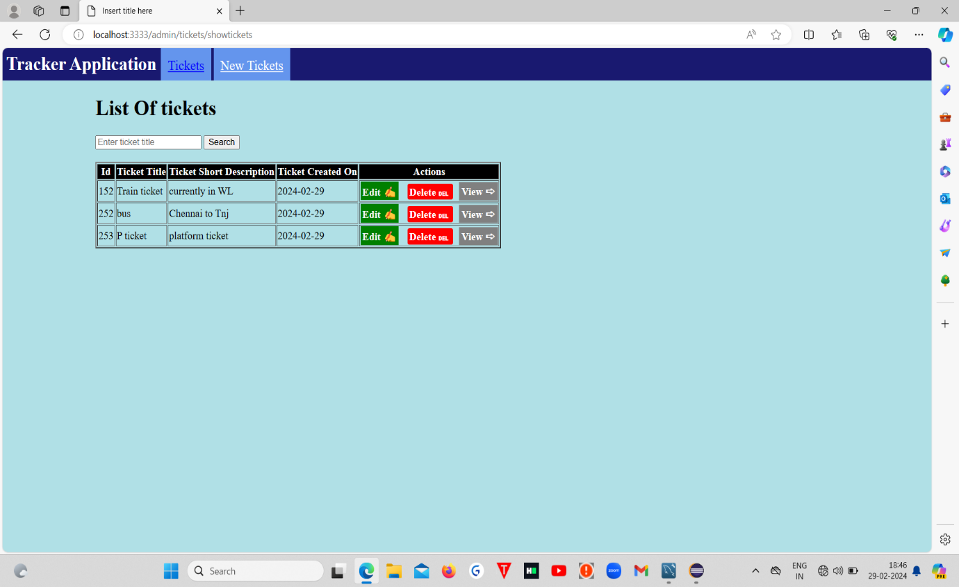:

***In This Application you can perform actions like***

* ***Add***
* ***Edit***
* ***Delete and***
* ***View tickets***

1. For Adding new Tickets you can click the “Add Ticket ” link in the top left side

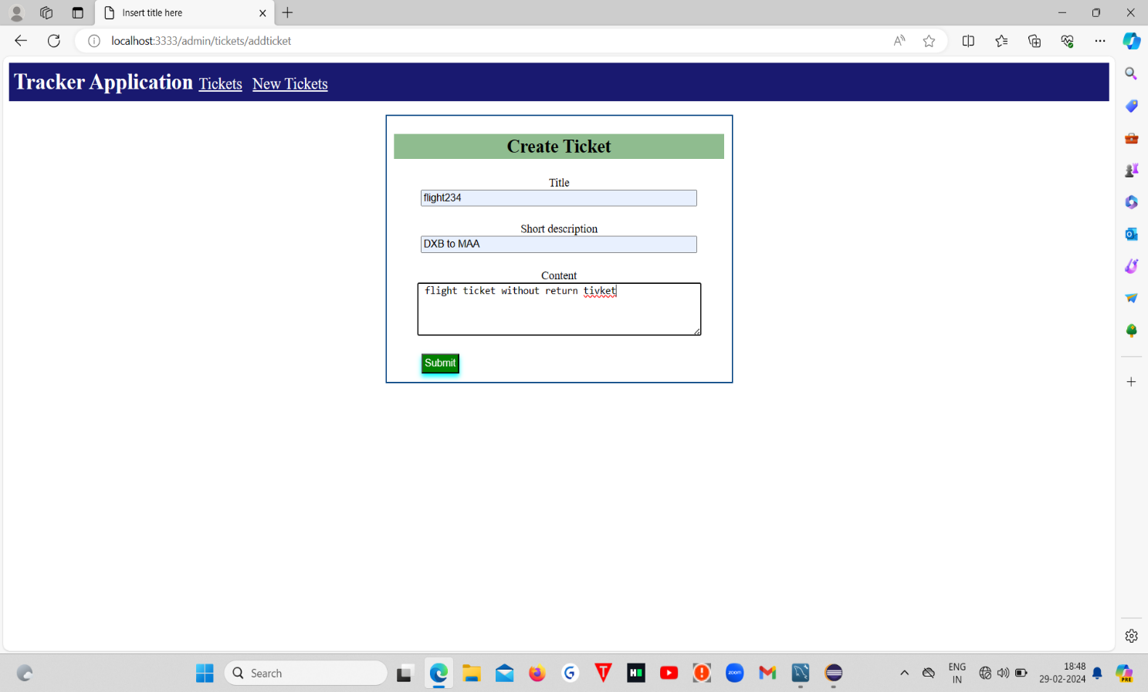

After Adding new Tickets click the submit button then your ticket will be added

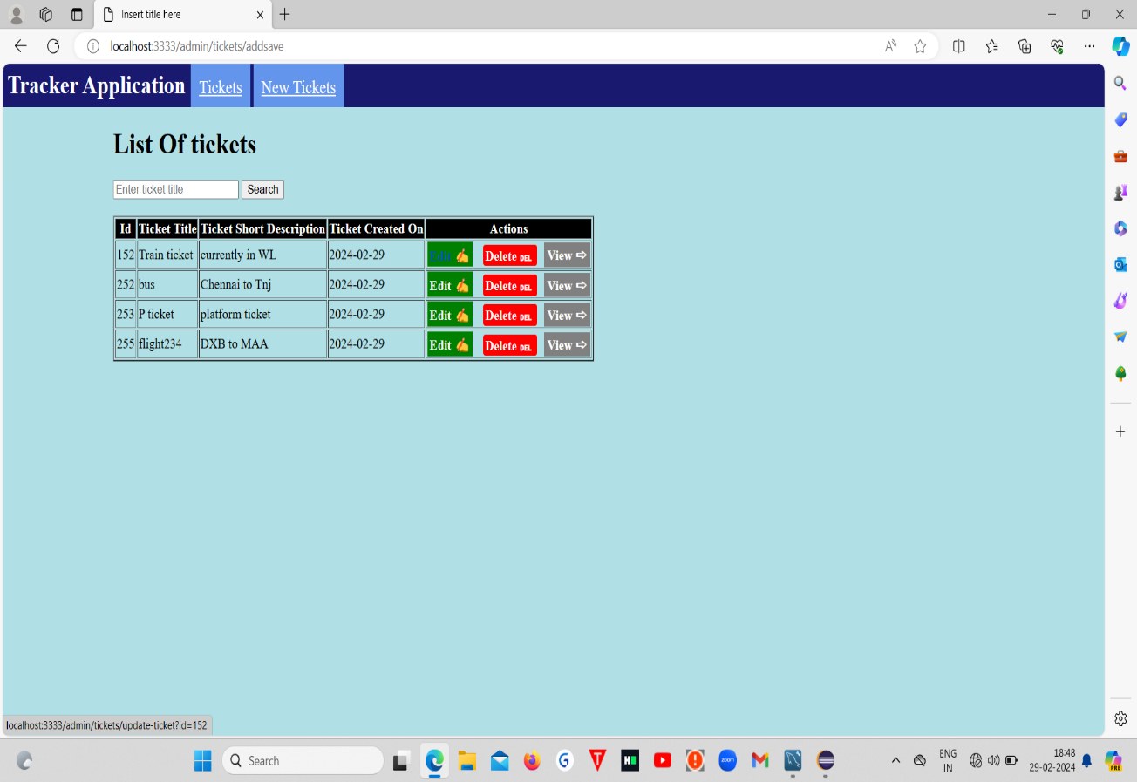

1. **For Edit/Update the ticket you can click that Edit Button in the Actions Column of the data you want to EDIT**

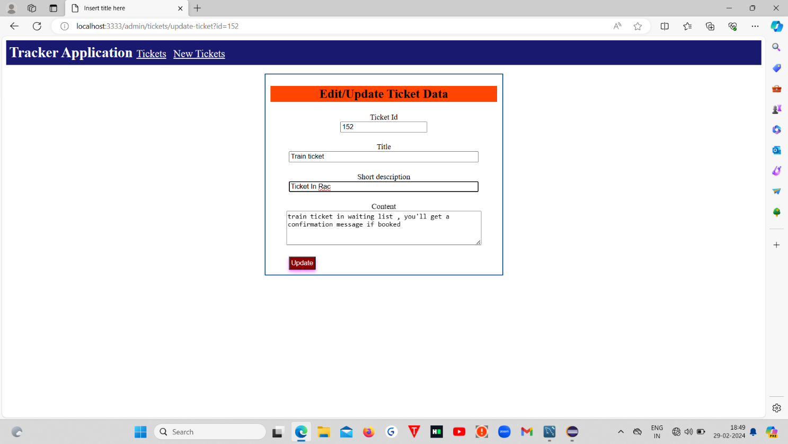

**You can Edit the data as your Wish, After Editing Click Update button to Update the data**

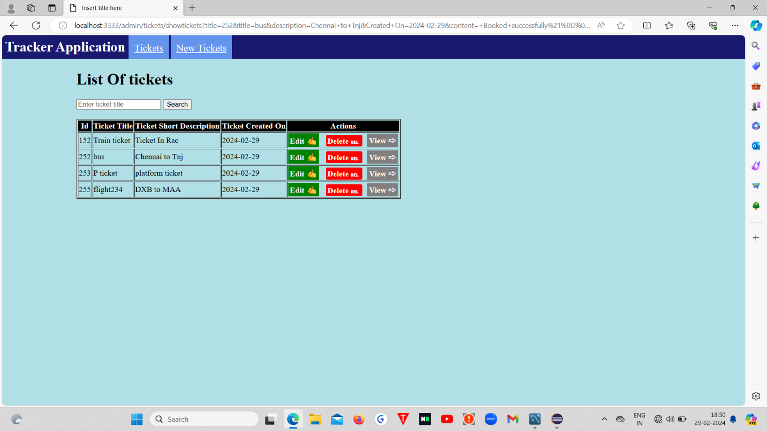

1. **To View the Contents of the Ticket , Click the View Link in the respective Row**

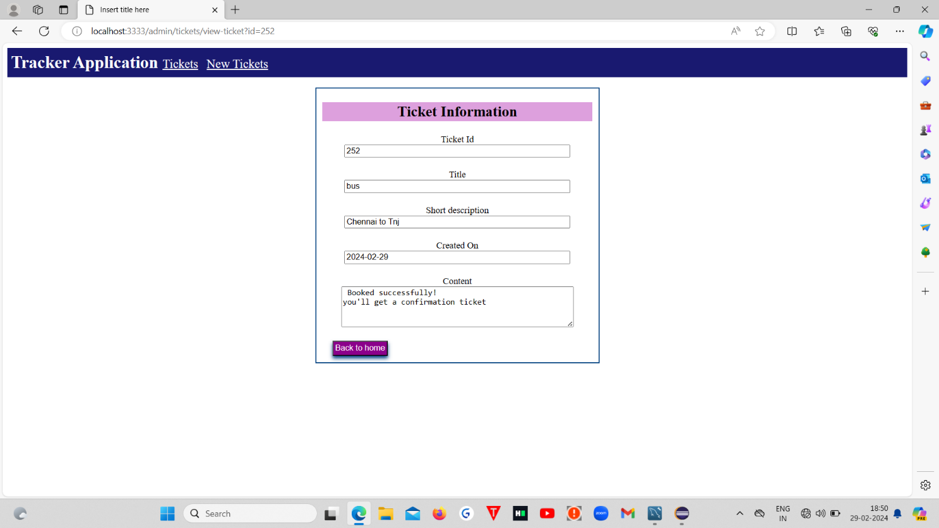

1. **To Delete the Contents of the Ticket , Click the Delete Link in the respective Row and the data will be deleted and show the current available tickets**

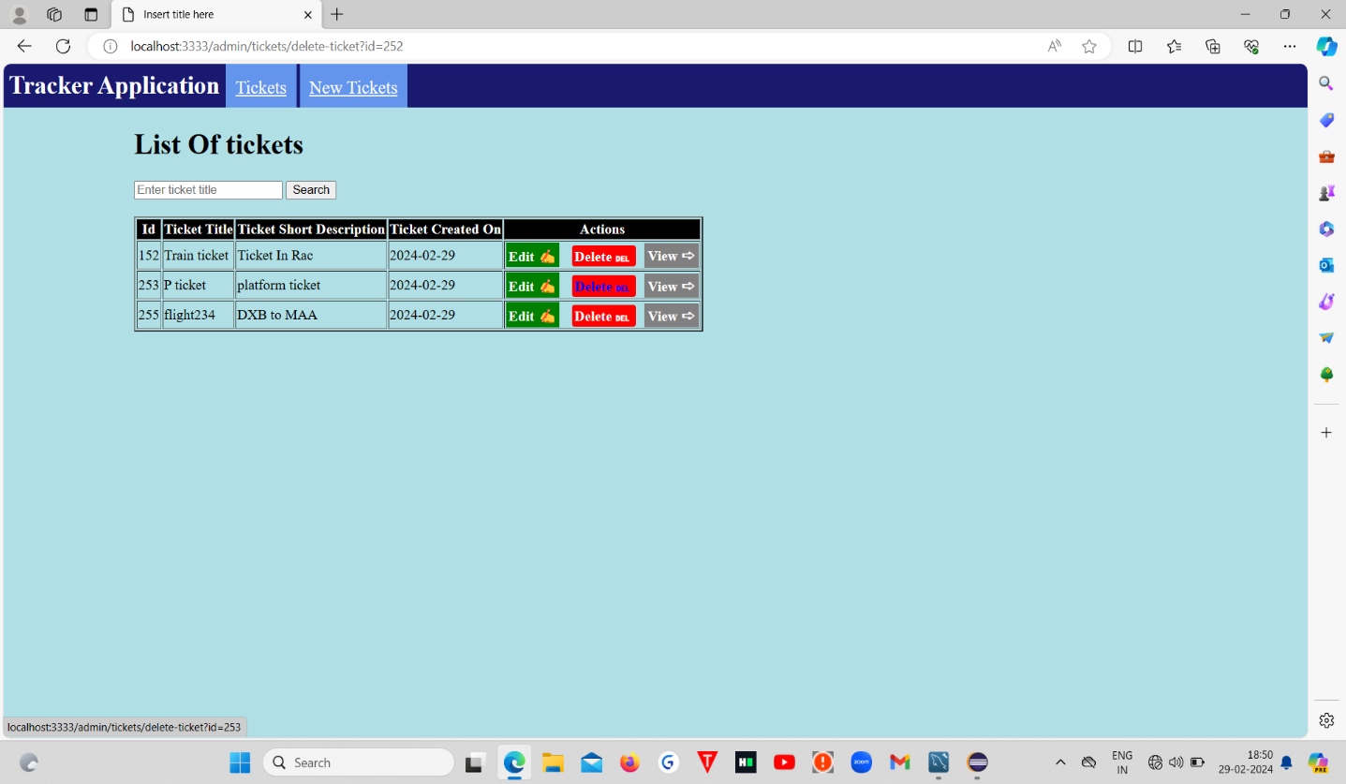

Finally All the Operations are Done ,

This is the Sql DB table in the back-end:

